Game Design Document

Fill up the following document

1. Write the title of your project.

Dungeon Master

1. What is the goal of the game?

Collecting treasure and unlocking next level.

1. Write a brief story of your game.

One day a detective found a map of treasure then he should go in the find of treasure and there he will find many obstacles and difficulties lets see the detective find the treasure or Not?

1. Which are the playing characters of this game?

* Playing characters are the ones who respond to the user based on the input from the user.
* Cars, monkeys, dinos, wizards, etc., are the playing characters in the game.

|  |  |  |
| --- | --- | --- |
| Number | Character Name | What can this character do? |
| 1 | detective | Move around the  Dungeon and collecting treasure |
| 2 |  |  |
| 3 |  |  |
| 4 |  |  |
| 5 |  |  |
| 6 |  |  |
| 7 |  |  |
| 8 |  |  |

1. Which are the Non-Playing Characters of this game?

* Non-Playing characters are the ones that don't have an action or behavior when the user interacts with the game.
* Hurdles, stones, bananas, coins, etc., are non-playing characters in the game.

|  |  |  |
| --- | --- | --- |
| Number | Character Name | What can this character do? |
| 1 | treasure | Score increase |
| 2 | key | Score increase |
| 3 | skeleton | Game over |
| 4 | throns | Game over |
| 5 | water | Game over |
| 6 |  |  |
| 7 |  |  |
| 8 |  |  |

Draw your imagination of this game. What does this game look like?

* Draw the game either on your computer or on paper.
* Add images of the game scenes to show each of the playing and non-playing characters at least once.

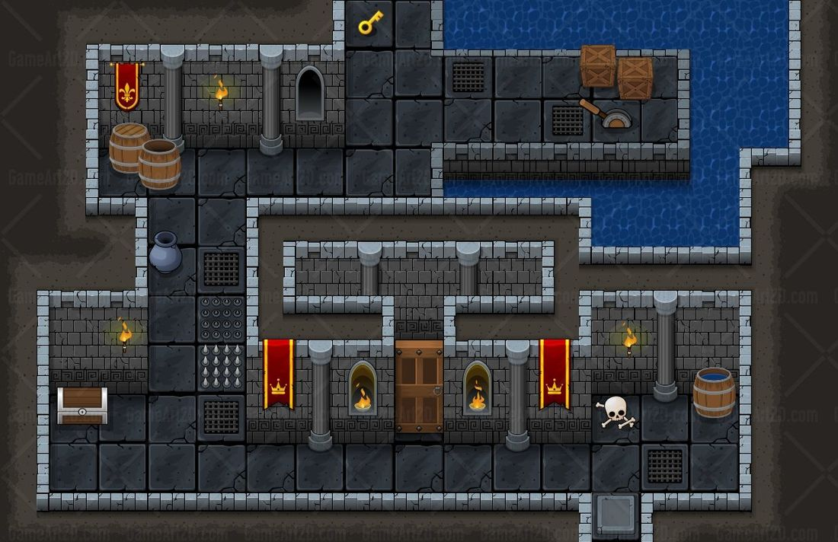

How do you plan to make your game engaging?

There will be three levels and many obstacles